**A PROJECT REPORT ON**

**PYTHON PROGRAMMING**

*Submitted by*

**AYUSHI SATISHBHAI PATEL**

**210410116081**

*In fulfillment for the award of the degree of*

## BACHELOR OF ENGINNEERING

***in***

INFORMATION TECHNOLOGY ENGINEERING



**Sardar Vallabhbhai Patel Institute of Technology, Vasad, Vadodara.**

## Gujarat Technological University, Ahmedabad

**April 2025**

 

## SARDAR VALLABHBHAI PATEL INSTITUTE OF TECHNOLOGY, VASAD.

INFORMATION TECHNOLOGY ENGINEERING 2024-25

**CERTIFICATE**

## Date:24/04/2025

This is to certify that the Summer Internship Work entitled “PYTHON PROGRAMMING” has been carried out by PATEL AYUSHI SATISHBHAI (210410116081) under my guidance in fulfillment of the degree of Bachelor of Engineering in Information Technology (8th Semester) of Gujarat Technological University, Ahmedabad during the academic year 2024-25.

Internal Guide Head of the

Department

Prof. Parita Parikh Dr. Mala H. Mehta

Asst. Prof. IT Dept.

SVIT, VASAD SVIT, VASAD

# CERTIFICATE

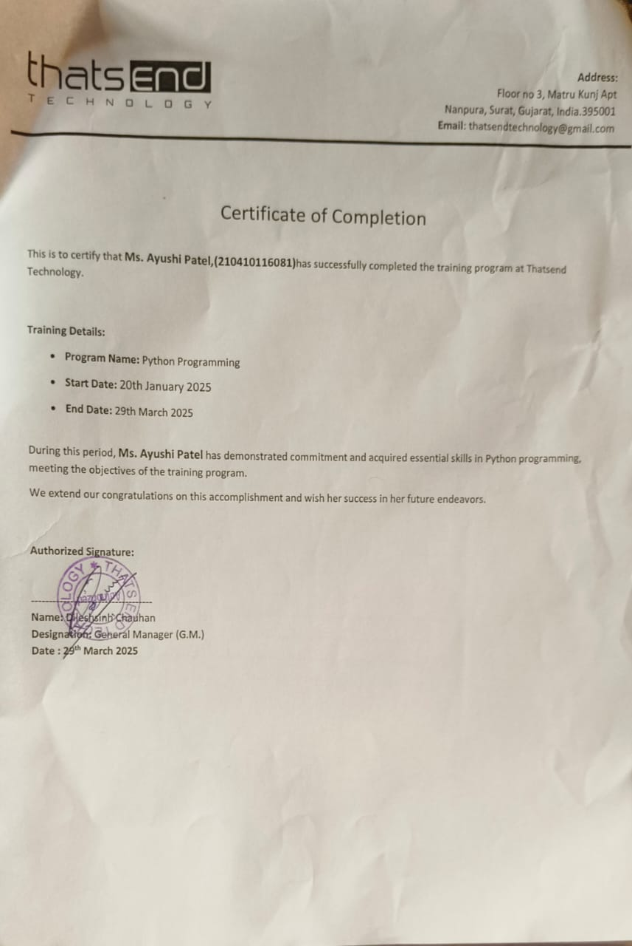

 

#### Sardar Vallabhbhai Patel Institute of Technology, Vasad, Vadodara

Vadodara-Mumbai National Highway 8, Vadodara, Gujarat 391240

# DECLARATION

We hereby declare that the Internship report submitted along with the Internship entitled **Python Programming Internship** submitted in partial fulfillment for the degree of Bachelor of Engineering in Computer Engineering to Gujarat Technological University, Ahmedabad, is a bono fide record of original project work carried out by me at **Thatsend Technology** under the supervision of **Mrs. Hiral Thakor** that no part of this report has been directly copied from any students’ reports or taken from any other source, without providing due reference.

**Name of the Student Sign of Student**

**Ayushi Satishbhai Patel**

**ACKNOWLEDGEMENT**

I want to thank all who have help me in making my internship successful. We are highly indebted **to Mr. Harikrishna Patel** and **Mrs.** **Hiral Thakor** their guidance and supervision. I would like to thank all faculty member and industrial worker for their co-operation and guidance.

This is first professional step toward our career in Information Technology field. So, we are thankful to IT Department and company to provide us opportunity of internship/vocational training. It has great experience of exposing as well as learning lot of new things during the whole journey with all the project members.

I would like to thank all from the bottom of my heart to head of the department **Prof. Parita**

**Parikh** and all the faculty members of information technology department and all our colleagues who directly or indirectly helped me in completion of internship and report.

# ABSTRACT

*For a web development internship project using Python, an abstract approach means designing the project in a way that hides complexity and makes the system modular, flexible, and maintainable. This project can use a web framework like Flask or Django and demonstrate the concept of abstraction throughout the system.*

*My objective for this internship was to gain practical experience in web development and learn about the industry's best practices. Additionally, I wanted to develop my technical and interpersonal skills and understand how to work collaboratively in a team environment.*

*This report describes my internship in Thatsend Technology is a leader in Technology Training Soft Skill Training and Recruitment solutions. Sardar Vallabhbhai Patel Institute of Technology provides that glorious opportunity to their student of having an internship within their bachelor program. During my internship I was introduced to some new technologies and languages. But the most amazing experience was to work in multicultural work environment culture.*

# 

# LIST OF FIGURES

# Figure No.

Figure2.9.1: PROGECT START 8

Figure2.9.2: ADMIN PANAL 8

Figure2.10.1: DATABASE 10

Figure 5.1.1: EMPLOYEE CRUDE MODUL 19

Figure 5.2.1.1: SIGN UP 20

Figure 5.2.3: HOME 21

Figure 5.2.4.1: PRODUCTS 23

Figure 5.2.4.2: PRODUCT DETAILS 23

Figure 5.2.6: CHECKOUT 24

Figure 5.2.7: FOOTER 24

Figure 6.1.1: CART 26

Figure 6.2.1: LOGIN 27

Figure 6.2.2: FORGOT 27

Figure 6.2.3: RESET 28

Figure 6.2.4: PROFILE 28

Figure 6.3.1: PAYPAL LOGIN 30

Figure 6.3.2: PAYMENT 30

Figure 6.3.3: INVOICE 32

Figure 6.4.1: User Accounts 33

Figure 6.4.2: Products Modul 33

Figure 6.4.3: Orders Modul 33

# LIST OF ABBREVIATIONS

# Terminology Meaning

ERD Entity Relationship Diagram

DFD Data Flow Diagram

HTTP Hyper Text Transfer Protocol

SQL Structure Query Language

DBMS Database Management System

IDE Integrated Development Environment

DBD Database Diagram

# 

# Table of Contents

**CERTIFICATE 3**

**DECLARATION iv**

**ABSTRACT vi**

**LIST OF FIGURS 7**

**LIST OF ABBREVIATIONS 8**

**CHAPTER-1:Introduction To Company…………………………………..………………………………….11**

**1.1 Introduction of the Company: 11**

**1.2 About Company:** 11

**1.3 Product and Services 12**

**CHAPTER-2: Introduction to Project 13**

**2.3 STATEMENT OF THE PROBLEM 13**

**2.4 THE SOLUTION 13**

**2.5 AIMS AND OBJECTIVES 14**

**2.6 SCOPE AND LIMITATION 14**

**2.5 RESEARCH METHODOLOGY 15**

**2.7 SIGNIFICANCE OF THE STUDY 15**

**2.8 DEFINATION OF TERMS 15**

**2.9 Setting Up Your Django Project** 16

**2.11 System Specifications 19**

**CHAPTER-3: System Design 21**

**Methods: 21**

**3.1 Architecture Design: 21**

**3.2** **Logical Design:** 21

**3.2.1 User Case Diagram:** 22

**3.1.1** **DFD Diagram:** 22

**3.2.3 Data Design: 23**

**3.2.4 ER Diagram: 24**

**3.2.5 Data Relationships 25**

**3.3 Physical Design: 25**

**CHAPTER-4: Literature Survey 26**

**4.1 STATUS OF ONLINE SHOPPING IN PERSENT BUSINESS ENVIOURNMENT 26**

**4.2 IMPORTANCE OF ONLINE SHOPPING 26**

**4.3 PROBLEMS OF ONLINE SHOPPING 26**

**4.4 THE FACTORS WHICH AFFECT ONLINE SHOPPING 27**

**4.5 PRIVACY AND SECURITY ISSUES IN ONLINE SHOPPING 27**

**CHAPTER-5: Implementation 28**

**5.1 Project: Crude Opration 28**

**5.2 Main Project: E commerce Website (LOTUS) 29**

**5.2.1 Registration 29**

**5.2.2 Navigation Bar 29**

**5.2.3 Home Page** 30

**5.2.4 Shop Page** 31

**CHAPTER-6: Result Analysis 33**

**6.1 Shopping Cart 33**

**6.2 Log in / Forgot / Reset 33**

**6.3 Payment Integration 36**

**6.4 Admin Penal 37**

**CHAPTER-7: Conclusion 39**

**CHAPTER-8: References 40**

**CHAPTER**-**1: Introduction To Company**



## 1.1 Introduction of the Company:

Company Name : Thatsend Technology

Address : Floor no 3, Matru Kunj Apt Nanpura, Surat, Gujarat, India 395001

Contact No: +91 78599 39199

Email Id : thatsendtechnology@gmail.com

Website: https://www.thatsend.com/

### 1.2 About Company:

Elevate your business with cutting-edge website design, development, and digital marketing services.We listen, understand, and deliver tailored solutions that exceed expectations. From startups to enterprises, our dedicated team ensures excellence, fostering long-lasting relationships. Trust Thatsend Technology for your IT and digital needs, and let us propel your success in the digital age.

Discover the power of seamless digital solutions with Thatsend Technology. Staying true to our motto "Your Problems, Our Solutions", our team offers a variety of services, Complete Business Solution /ERP Responsive Website Design & Development, E-commerce Development, Management System Development, UI LUX, UI/UX Design, B2B / B2C / C2C Portal Development, Cloud & External Services to say the least.

## 

## 

## 1.3 Product and Services

* Complete Business Solution /ERP
* Responsive Website Design & Development
* E-commerce Development
* Management System Development
* UI LUX
* UI/UX Design
* B2B / B2C / C2C Portal Development
* Cloud & External Services
* Social Media Service Integration
* Readymade Solution Setup & Integration
* Support & Maintenance Services
* Mobile Application Development
* Desktop Solutions

# 

# CHAPTER-2: Introduction to Project

**2.1: Project Summary:**

The Django eCommerce Website is a robust, full-featured online shopping platform built using the Django web framework. This project is designed to replicate real-world eCommerce functionality, optimized for smooth user experience, scalability, and ease of management from both customer and admin perspectives

**2.2: Core Technologies Used:**

* Backend: Django (Python)
* Frontend: HTML5, CSS3, JavaScript, Bootstrap
* Database: My SQL
* Authentication: Django's built-in auth system
* Payments: PayPal (can be customized)
* Deployment Ready: Heroku, AWS, or any cloud hosting

# 2.3 STATEMENT OF THE PROBLEM

Traditionally, customers are used to buying the products at the real, in other words, factual shops or supermarkets. It needs the customers to show up in the shops in person, and walk around different shopping shelves, and it also needs the owners of shops to stock, exhibit, and transfer the products required by customers. It takes labour, time and space to process these operations.

Furthermore, the spread of the Covid-19 pandemic has caused a lot of changes in our lifestyle, people fearing to get outside their homes, transportation almost shut down and social distancing becoming all the more important. Big to small scale business that relied on the traditional incur a lot of consequence due to the lockdown issues. Some tend to more towards using social media platforms like Facebook to sell their product. However, the social media platforms have been beneficial for marketing purposes alone but leaves the whole task of customer and massive order management via direct messaging (DM), which takes a lot of time to respond to all customers. In addition, everyone tends to use social media, posing a great challenge to differentiate between scammers (fraudsters) and legit sellers.

# 2.4 THE SOLUTION

Lotus Fashions Store is an Online shopping system provides a solution to reduce and optimize these expenses. Authorized Customers do not need to go to the factual shops to choose, and bring the products they need by hands. They simply browse their Personal computers or cell phones to access shops, and evaluate the products description, pictures on the screen to choose products. In addition, the owners of the shop do not need to arrange or exhibit their stocks products. They just input the description, prices of products, and upload their pictures. Simply, both customers and shop owners do not need to touch the real products in the whole process of shopping, and management. In the end the logistic centre will distribute the products required by customers, or products ordered by shop owners to their locations. The customers are able to track the status of their orders until delivery, after which they can leave a review of the type of service they received. The payment and products’ quantity will be saved in database through the data flow.

# 2.5 AIMS AND OBJECTIVES

The main objective of the study is to develop an online fashion brochure system. The system aims to achieve the following objectives:

* To design an online fashion system.
* To provides a solution to reduce and optimize the expenses of customer order management
* To create an avenue where people can shop for fashion products online.
* To develop a database to store information on fashion products and services.

# SCOPE AND LIMITATION

Every project is done to achieve a set of goals with some conditions keeping in mind that it should be easy to use, feasible and user friendly. As the goal of this project is to develop an online fashion brochure system, this system will be designed keeping in mind the conditions (easy to use, feasibility and user friendly) stated above. It may help in effective and efficient order management. In every shot time, the collection will be obvious, simple and sensible. It is very possible to observe the customer potentials and purchase patterns because all the ordering history is store in the database. It is efficient managing all the operations of an online store within a single platform. The project aims to automate the business process of La BELLE Fashion store. The proposed project would cover:

**Customer Side**

* Customer can view/search products without login.
* Customer can also add/remove product to cart without login (if customer try to add same product in cart. It will add only one)
* When customer try to purchase product, then he/she must login to system.
* After creating account and login to system, he/she can place order.
* If customer click on pay button, then their payment will be successful and their order will be placed.
* Customer can check their ordered details by clicking on orders button.
* Customer can see the order status (Pending, Confirmed, Delivered) for each order
* Customer can Download their order invoice for each order
* Customer can send feedback to admin (without login)

**Administrator Side**

* Admin can provide username, email, password and your admin account will be created.
* After login, there is a dashboard where admin can see how many customers is registered, how many products are there for sale, how many orders placed.
* Admin can add/delete/view/edit the products.
* Admin can view/edit/delete customer details.
* Admin can view/delete orders.
* Admin can change status of order (order is pending, confirmed, out for delivery, delivered)
* Admin can view the feedbacks sent by customers

Additionally, if customer places order and admin deleted that user (fraud detection), then their orders will automatically be deleted. Suppose one (1) customer places four (4) products order and admin deleted two (2) product from website, then that two-product order will also be deleted and other two will be there. Also, if user click on purchase button without having products in their cart, then website will ask to add product in cart first.

On the contrary, designing web applications is characterized by some constraints and limitations. Developers are limited to a small set of graphical widgets for use in presenting a user interface. Web-based applications require high investment in software, as well as maintenance costs for the software and personnel for software administration. In this study, verification of credentials for membership cannot be done. Besides, there is a payment page although just for demo.

Customers are advised to fill in pseudo details (DONT FILL YOUR ORIGINAL CARD DETAILS THERE). By the way, website do not save these details.

# RESEARCH METHODOLOGY

The research method used for this project work is quantitative research reviews the current system, provide its description, identifying the discrepancies and eventually giving a suitable solution. Therefore, the method used in the design and collections of information from various sources are as follows:

* Studying the present system in detail and the organizational style.
* Knowing and understanding the input and output processes of the existing system.
* A qualitative form of interview was conducted in the organization to understand the mode of operation of the old system.

# 2.7 SIGNIFICANCE OF THE STUDY

With the aid of an efficient information system, fashion associations can be able to react quickly by giving out information about changes in the market and latest trends to the public. An online application not only saves time and money, but also minimizes administrative efforts and cost. It provides an avenue to market products to a whole new audience.

Here are benefits of having an La BELLE Fashion brochure system;

* Easy advertisement of new products and services
* Saves time on the part of the buyer due to the fact that they can do transactions for any product or make enquiries about any product or services provided by a company anytime and anywhere.
* It creates an avenue for expansion to national and international markets.
* An online fashion brochure system improves the brand image of a company.
* It aids a fashion company in providing better customer service.
* It helps to simplify business processes and make them faster and more efficient.

# 2.8 DEFINATION OF TERMS

* **Fashion:** fashion is a distinctive and often habitual trend in the style in which a person dress.
* **Fashion design:** fashion design is the art of the application of design and natural beauty to clothing and accessories.
* **Fashion designer:** a fashion designer is someone who loves to study fashion trends, sketch designs, select materials, and have a part in all the production aspects of their designs. they contribute to the creation of millions, if not billions of pieces of clothing and accessories purchased by consumers on a yearly basis. fashion designers create women’s, men’s and children’s apparel. this might include sportswear, maternity wear, outerwear, underwear, formalwear, eyewear and footwear. there are also accessory designers who design belts, scarves, hats, handbags and hosiery.
* **Association:** an association is an organized body of people who have an interest, activity, or purpose in common; a society.
* **Web based application:** a web-based application is a software package that can be accessed through the web browser. the software and database reside on a central server rather than being installed on the desktop system and is accessed over a network.
* **Web browser:** a web browser is a software application used to enable computer users locate and access web pages.
* **Brochure:** a brochure is an advertising piece mainly used to introduce a company or an organization and inform about products or services to a target audience.
* **E-commerce:** electronic commerce is the buying and selling of goods and services, or the transmission of funds or data, over an electronic network, primarily the internet.
* **Catalogue:** a product catalogue is a file that contains a list of all the products you want to advertise. Each line of the product catalogue contains a description of each product, including an id, name, category, availability, product URL, image URL and other product attributes.

### 2.9 Setting Up Your Django Project

### Step 1: Setting Up Your Django Project

First, ensure you have Django installed. If not, you can install it using pip:

-pip install Django

Next, create a new Django project and navigate into the project directory:

-django-admin startproject lotus

-cd lotus

Step 2: Create Virtual Envirnment And Activate It

Within your project, create a new app called products:

- python -m venv venv

Windows:

-venv\Scripts\activate.bat

Unix/MacOS:

-source venv/bin/activate

Step 3: CreatE a Products App

Within your project, create a new app called products:

-python manage.py startapp store

Step 4: Run Migrations

Create the necessary database tables by running migrations:

-python manage.py makemigrations

-python manage.py migrate

Step 5: Add Products through the Admin Interface

Create a superuser to access the admin interface:

-python manage.py createsuperuser

Run the development server:

-python manage.py runserver

Log in to the admin interface at <http://127.0.0.1:8000/admin/>

### Figure2.9.1: PROGECT START

### Your first Django project! · HonKit

### Figure2.9.2: ADMIN PANAL

### 

**2.10 To Connect The Database**

**In settings.py**

"default": {

"ENGINE": "django.db.backends.mysql",

"NAME": "lotus",

"USER": "",

"PASSWORD": "*****",

"HOST": "127.0.0.1",

"PORT": "3306",

}

### Figure2.10.1: DATABASE

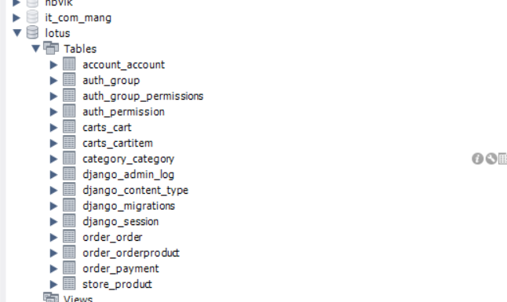

# System Specifications

This section describes the hardware components and software requirements needed for effective and efficient running of the system

# Table: 1 Hardware Requirements

|  |  |  |
| --- | --- | --- |
| **SL** | **Hardware** | **Minimum System Requirement** |
| 01 | Processor | 2.4 GHz Processor speed |
| 02 | Memory | 2 GB RAM |
| 03 | Disk Space | 500 GB |

**Table: 2 Software Requirements**

|  |  |  |
| --- | --- | --- |
| **SL** | **Software** | **Minimum System Requirement** |
| 01 | Operating System | Windows 8, Windows 10 or MAC Ox 10.8,10.9, or 10.11, LINUX |
| 02 | Database Management System | My SQL |
| 03 | Runtime Environment | PyCharm or Visual Studio Code |

# 

# CHAPTER-3: System Design

# Methods:

# 3.1 Architecture Design:

To describe the views, models, behavior, and structure of the system.

### Logical Design:

To represent the data flow, inputs, and outputs of the system. Example: User Case Diagram

### 3.2.1 User Case Diagram:

### Online Shopping System

### DFD Diagram:

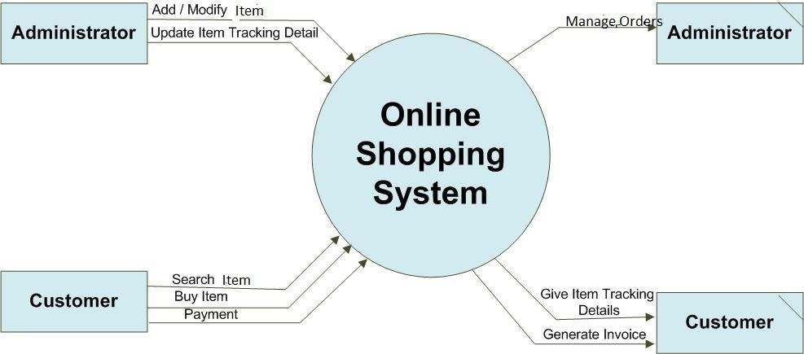

# 3.2.3 Data Design:

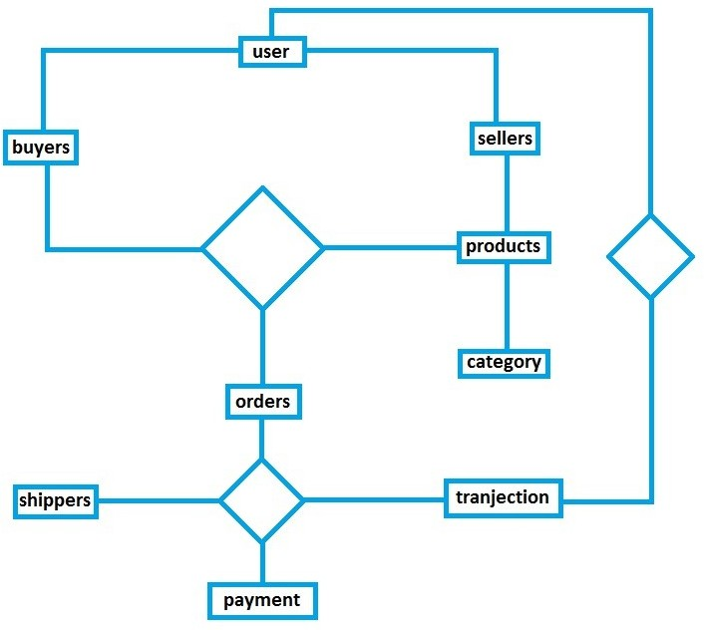

# 

# 3.2.4 ER Diagram:

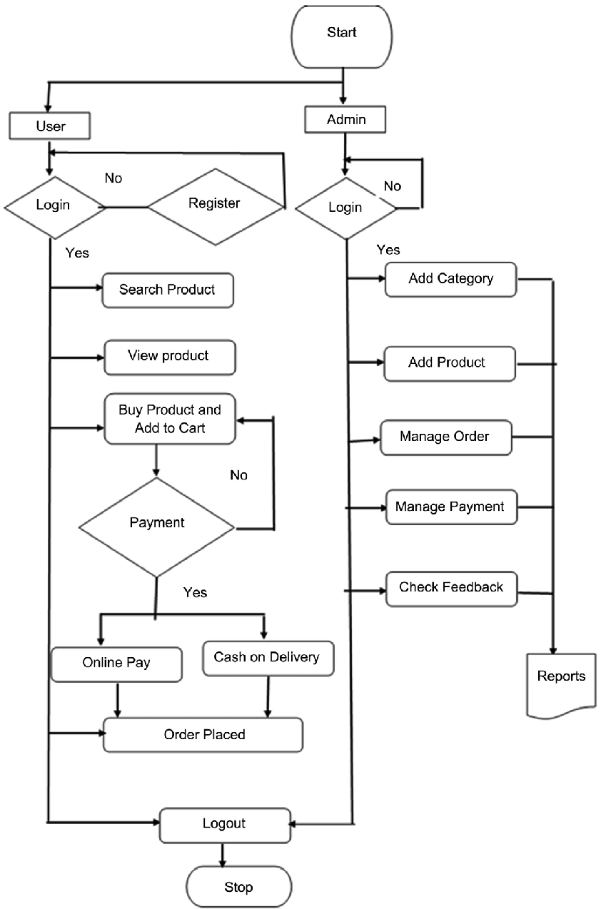

# Data Relationships

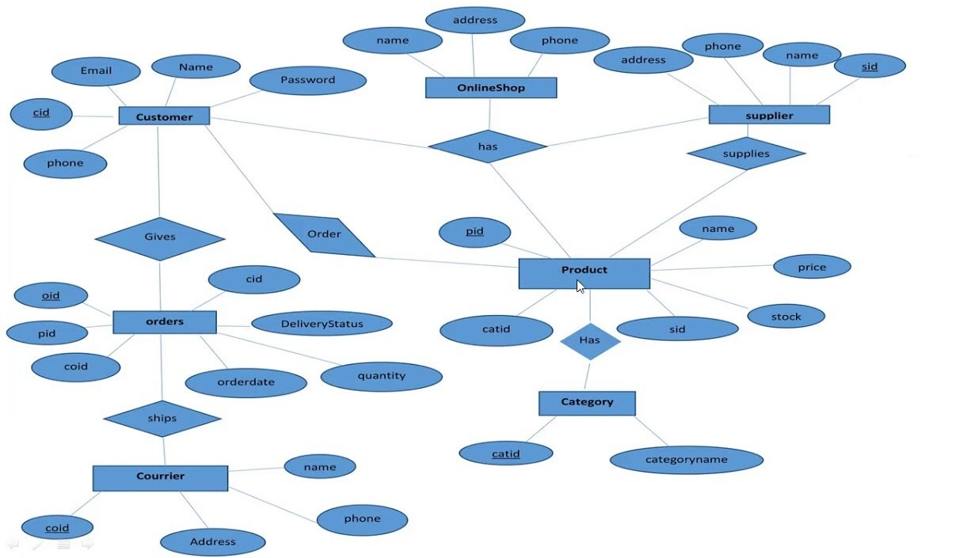

# 3.3 Physical Design:

Define as:

* How users add information to the system and how the system represents information back to the user.
* How the data is modelled and stored within the system.
* How data moves through the system, how data is validated, secured and /or transform as it flows through and out of the system.

# CHAPTER-4: Literature Survey

**INTRODUCTION**

Literature review is an expressive study based on the detailed review of earlier pertinent studies related to the various concepts of online shopping to discover the concept of online shopping. It highlights the status of online shopping, importance and problems of online shopping, factors affecting online shopping and a critical review of the privacy and security issues in online shopping.

# STATUS OF ONLINE SHOPPING IN PERSENT BUSINESS ENVIOURNMENT

Online buying behaviour is affected by various factors like, economic factors, demographic factors, technical factors, social factors, cultural factors, psychological factors, marketing factors and legislative factors. Customers choose an online-shop mainly based on references, clarity terms of delivery, graphic design and additional services. Problematical customers read discussions on the Internet before they spend their money on-line and when customers are incapable to purchase the product fast and with no trouble they leave online-shop.

# IMPORTANCE OF ONLINE SHOPPING

Ling, said that customers can take enjoy online shopping for 24 hour per day. Consumers can purchase any goods and services anytime at everywhere. Online shopping is user friendly compare to in store shopping because consumers can just complete his requirements just with a click of mouse without leaving their home. Online shopping has some advantages like below.

Save the Time of the consumers.

They can purchase any time anywhere.

They can compare the price with the others retailers very easily.

Compare the advertising price and actual price.

They can easily track their product.

They can use cash back policy.

They can purchase the product from the foreign marketers.

# 4.3 PROBLEMS OF ONLINE SHOPPING

Online shopping problems are great barrier to the online purchase aim of customers. General problems include prospect of having credit card. The obscurity to confirm the reliability of the provide goods and the risk to buy a product that it would not value as much as customer pay for it. Aftersales problems, involved difficulty to change not working product with a new one and products warranty are not assured. Online shopping has various disadvantages:

* + - The customers can not touch and fell of the products when they want to Purchase.
    - Some time delivery time is so much late
    - Some time they will pay the shipping charges so why the cost of the product may increase.
    - Lack of personal attention by the sellers. More chance to fraud.
    - Security of internet banking password and credit card password
    - Lack of quality.

# 4.4 THE FACTORS WHICH AFFECT ONLINE SHOPPING

There are some factors which affect the online shopping by the Kotler who is a great marketing writer

* + - Convenience (no traffic, crowds,24 hr. access
    - Product Selection

# PRIVACY AND SECURITY ISSUES IN ONLINE SHOPPING

Shopping online has never been so easy. With the flourishing numbers of online merchants, people nowadays have various choices to do their shopping. Big companies such as eBay and amazon.com have introduced many values added features to help the customers to decide what to shop for. With features such as price comparison, product photos and user reviews, consumers can shop easily and smartly without even going to the stores and having such a hard time looking for the products they want. All they have to do are just browse for the product they want in the website and within a few mice clicks they are off. Such simplicity is what makes online shopping appealing for consumers. The question is, why do many people still deny to shop online? Well, for most people, privacy and security issues are their concerns. Hence, here I will discuss customers’ perception of privacy and security issues, the reality of such issues and ways to avoid those issues, all based on some trustworthy sources I have found.

# 

# CHAPTER-5: Implementation

# 5.1 Project: Crude Opration

The crude operation based employ management web application with the authentication process.

* Add, update, and delete employee

### Figure 5.1.1: EMPLOYEE CRUDE MODUL

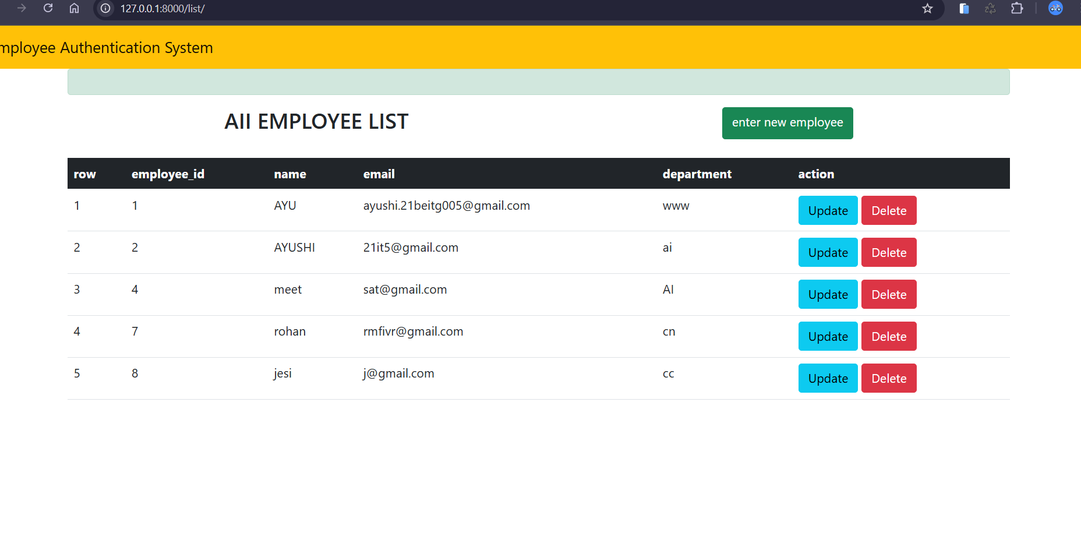

# 5.2 Main Project: E commerce Website (LOTUS)

# 5.2.1 Registration

In this page I have created the sign up page with the help of the bootstrap template and rest of the authentication is done with the Django frame work in account app in Django project

**User Authentication & Profile Management**

* User registration and login/logout system
* Password reset via email

### Figure 5.2.1.1: SIGN UP

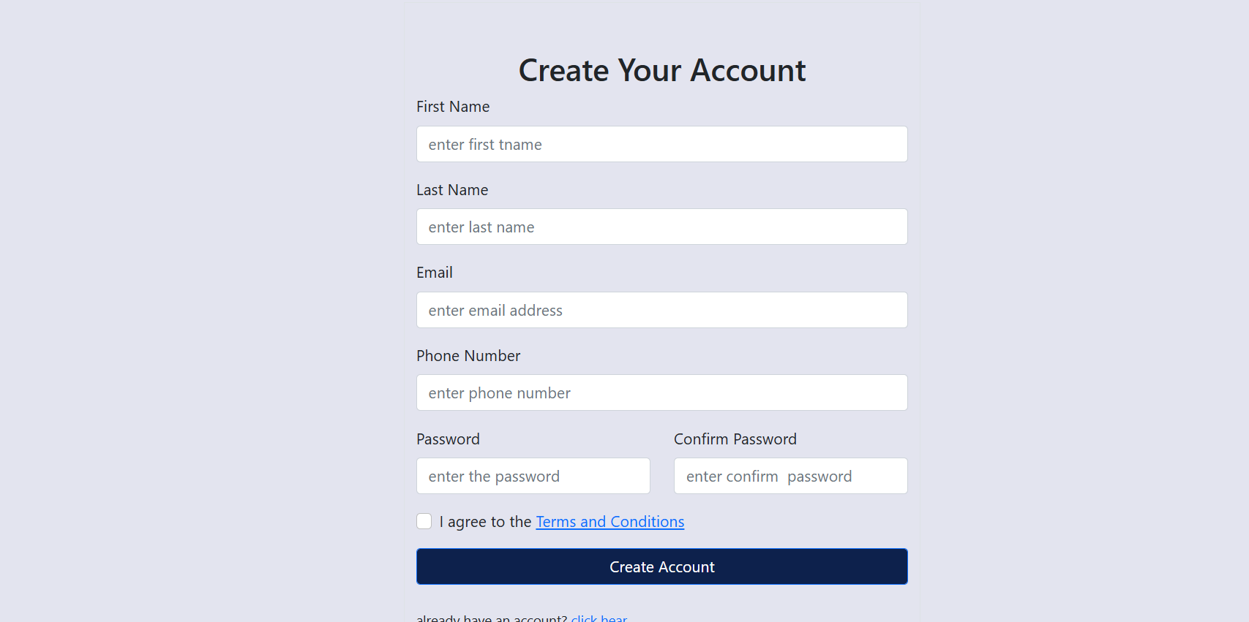

# 5.2.2 Navigation Bar

You can see the navigation bar in the picture which is done by bootstrap navigation bar properties and values. hover effect is also given to the each navigation link.

# Figure 5.2.2.1: NAVIGATION BAR

 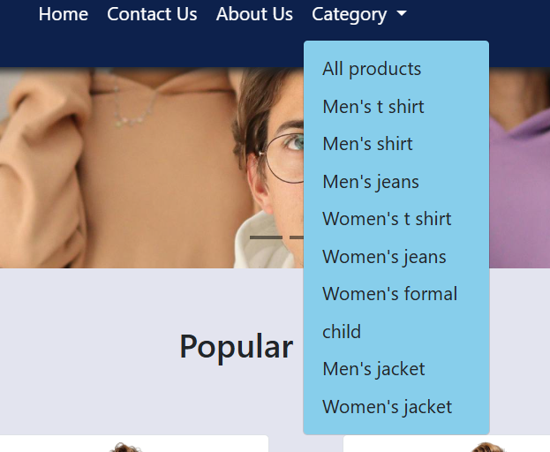

### 5.2.3 Home Page

This is the home section of the web page.in this section I have put the slide show of pictures.

### Figure 5.2.3: HOME



### 5.2.4 Shop Page

In this section I’ll get knowledge about advanced crude operation to add images in the section for shopping new cloths.

Product Ceta log & Product Details

### Dynamic product listings with categories, tags, and filters

### Product detail pages with images, descriptions, pricing

### Figure 5.2.4.1: PRODUCTS

### 

### Figure 5.2.4.2: PRODUCT DETAILS

### 

### Figure 5.2.6: CHECKOUT

### 

### Figure 5.2.7: FOOTER



# CHAPTER-6: Result Analysis

# 6.1 Shopping Cart

* Add, update, and remove items from the cart.
* Quantity management in cart.

# Real-time total calculation.

# Figure 6.1.1: CART

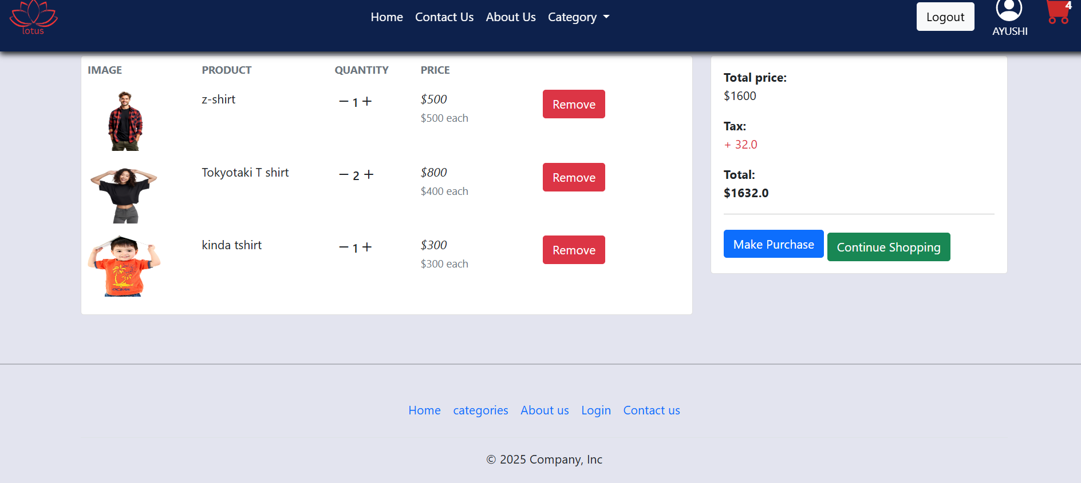

# 6.2 Log in / Forgot / Reset

* User can log in.
* User can reset password in profile page.
* User can forgot password through the email link to user.

# Figure 6.2.1: LOGIN

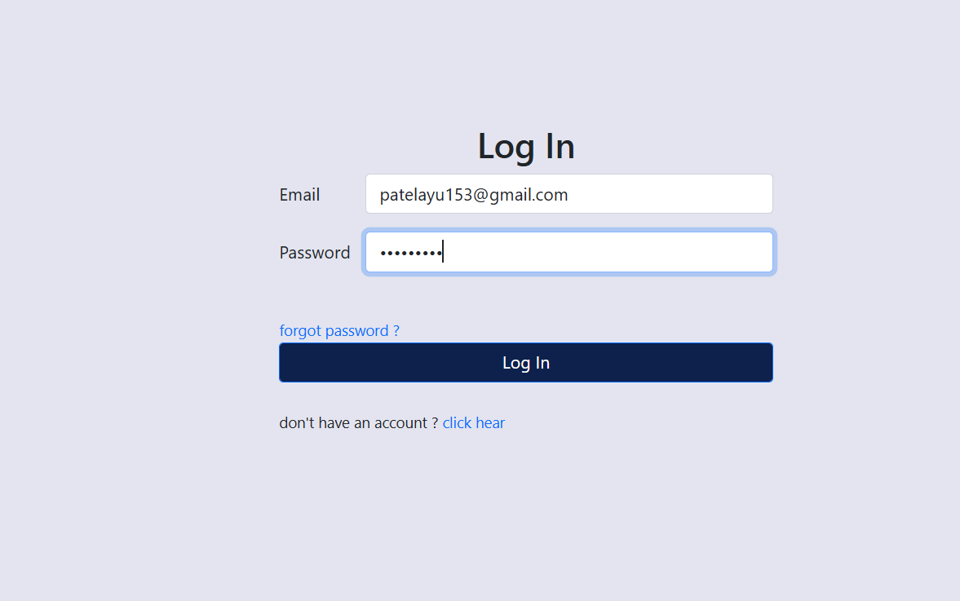

# Figure 6.2.2: FORGOT

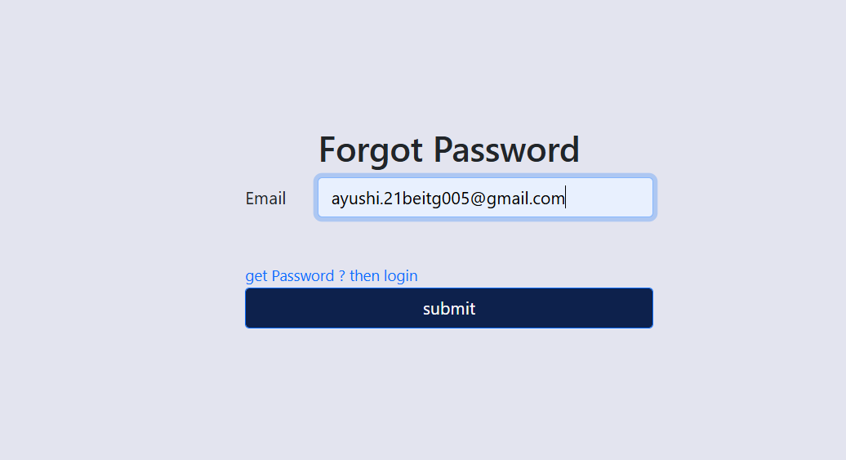

# Figure 6.2.3: RESET

# 

# Figure 6.2.4: PROFILE

# 

# 6.3 Payment Integration

* Secure checkout using PayPal
* Transaction confirmation and order number generation
* Invoice generation and download also available.

### Figure 6.3.1: PAYPAL LOGIN

### 

# Figure 6.3.2: PAYMENT

### 

### Figure 6.3.3: INVOICE

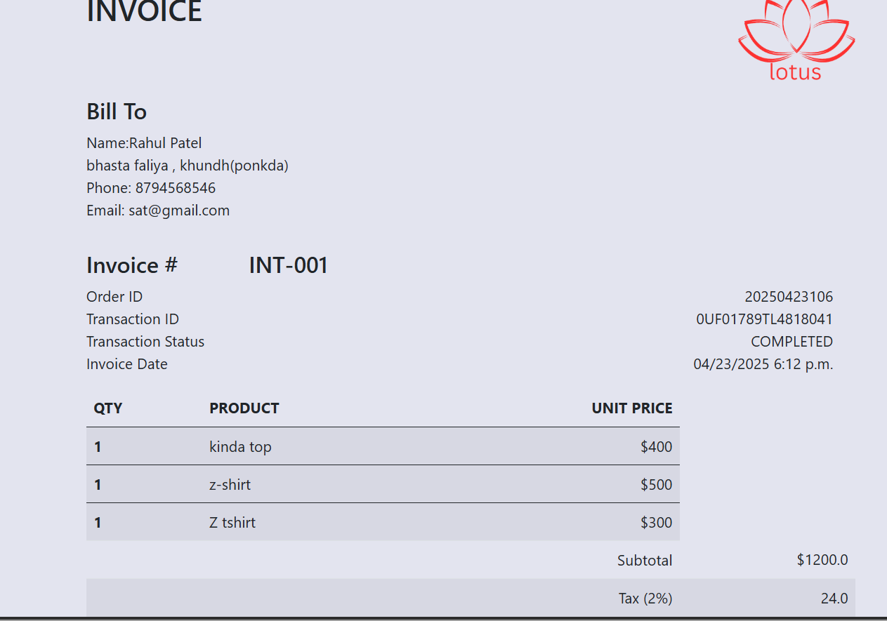

# 6.4 Admin Penal

* Here admin can change the category.
* Add products, delete products.
* Manage the order details.

# 

# Figure 6.4.1: User Accounts

# 

# Figure 6.4.2: Products Modul

# 

# 

# Figure 6.4.3: Orders Modul

# 

# 

# CHAPTER-7: Conclusion

The work experiences I encountered during the internship allowed me to develop my html and CSS, python knowledge. I think I still require to work on my other skills required for web designing.

But,the overall experience was positive, and everything I learned would be useful in my future career in this field. I utilize my time and energy to acquire as much knowledge and skills as possible. I managed to adapt myself to the working environment with the support from the supervisor and other employees of the company.

I had encountered several difficulties during the internship period. The first difficulty that I faced was the inexperience and knowledge about bootstrap. It’s a very big challenge for me to pick up the method within a short time. However, I had finally known about the bootstrap and managed the difficulties that I have faced successfully.

During my internship I was introduced to some new technologies and languages. But the most amazing experience was to work in multicultural work environment culture.

I am extremely satisfied by this internship and I am grateful to Thatsend Technology for providing me opportunity to do an internship in their company

# CHAPTER-8: References

# For the project the web link references were:

* <https://maxcdn.bootstrapcdn.com/bootstrap/3.4.1/css/bootstrap.min.css>
* <https://ajax.googleapis.com/ajax/libs/jquery/3.6.4/jquery.min.js>
* <https://maxcdn.bootstrapcdn.com/bootstrap/3.4.1/js/bootstrap.min.js>
* https://docs.djangoproject.com/en/5